# Set up Web environment

## Use IntelliJ to Open our project: File -> Open

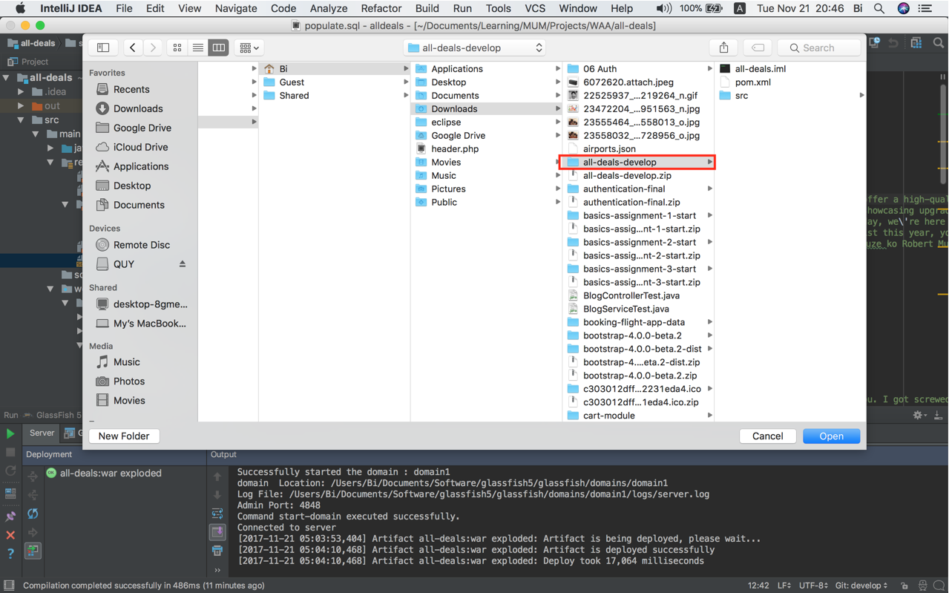

## Right click on Folder name -> Add Framework Support…

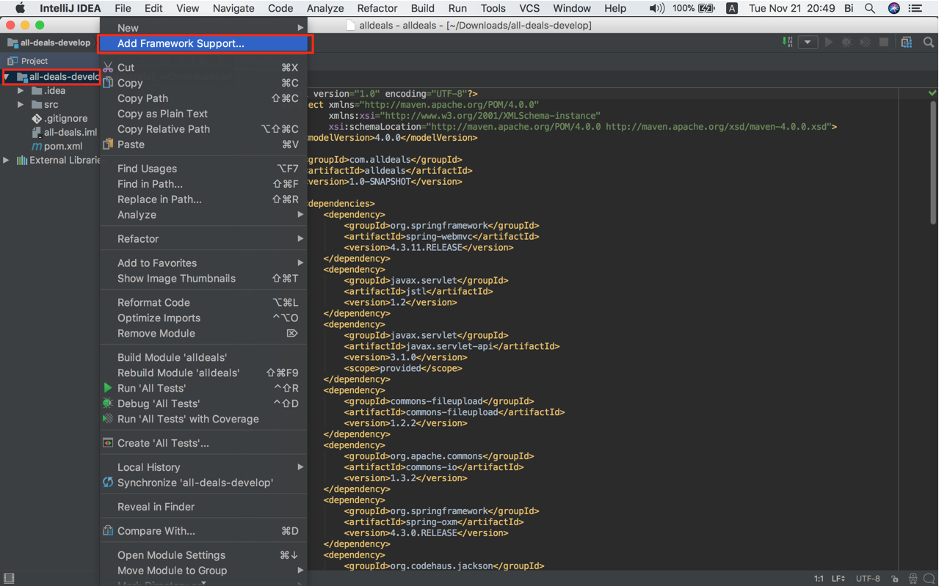

## Check on Web Application -> OK

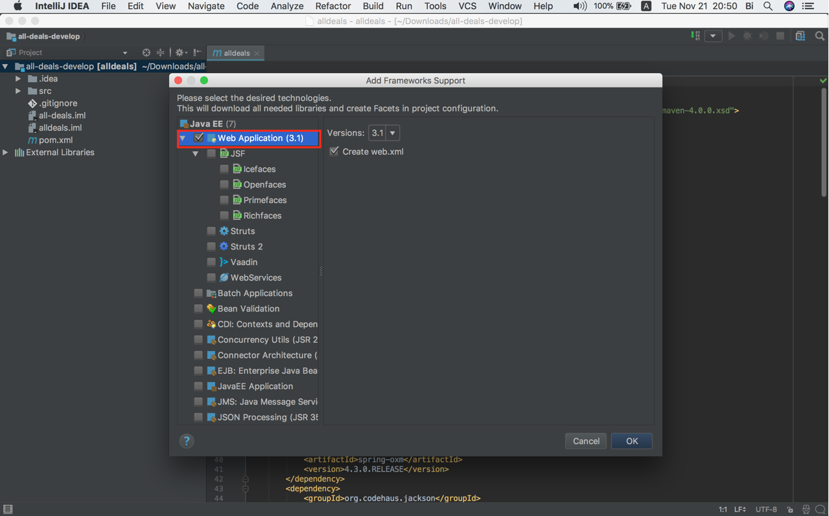

## Delete the folder “web” folder that was created automatically

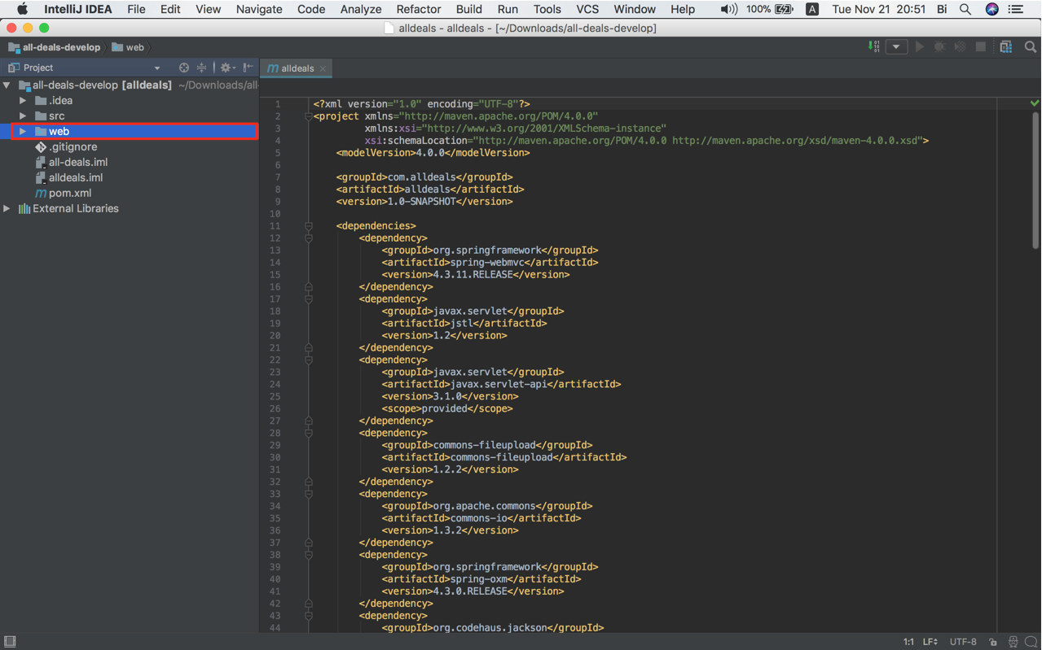

## Select File -> Project Structure…

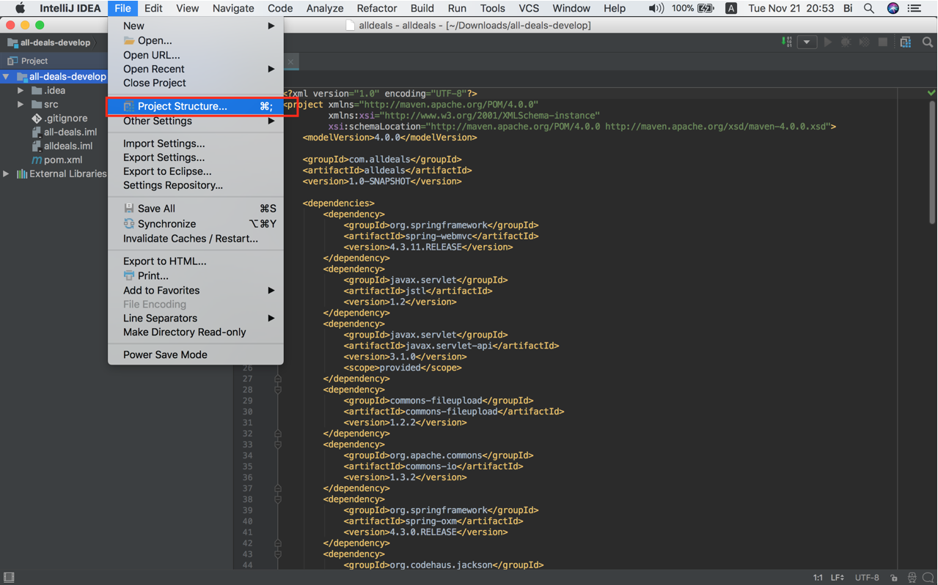

## Select Facets -> Web -> Web Resource Directory -> Edit icon

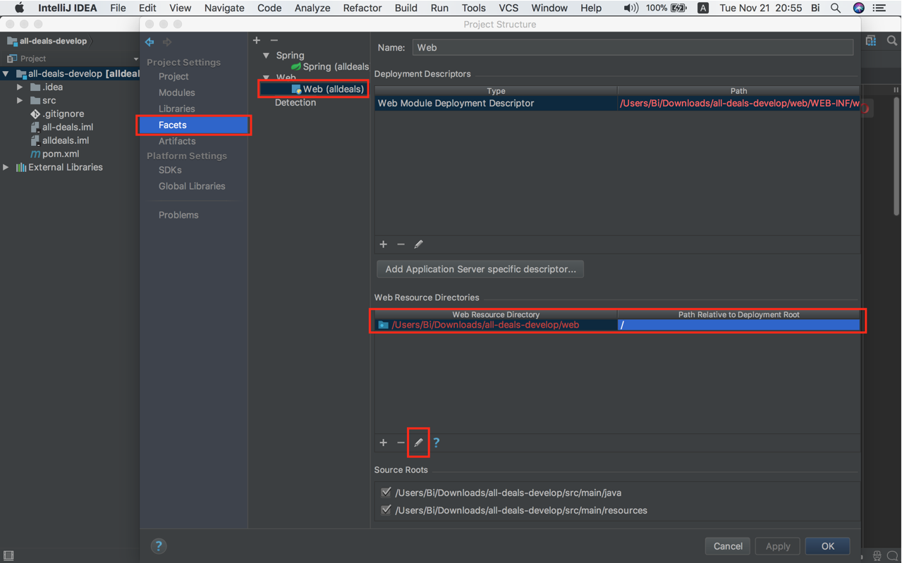

## Browse to “webapp” folder under “main” folder -> OK -> OK again to close

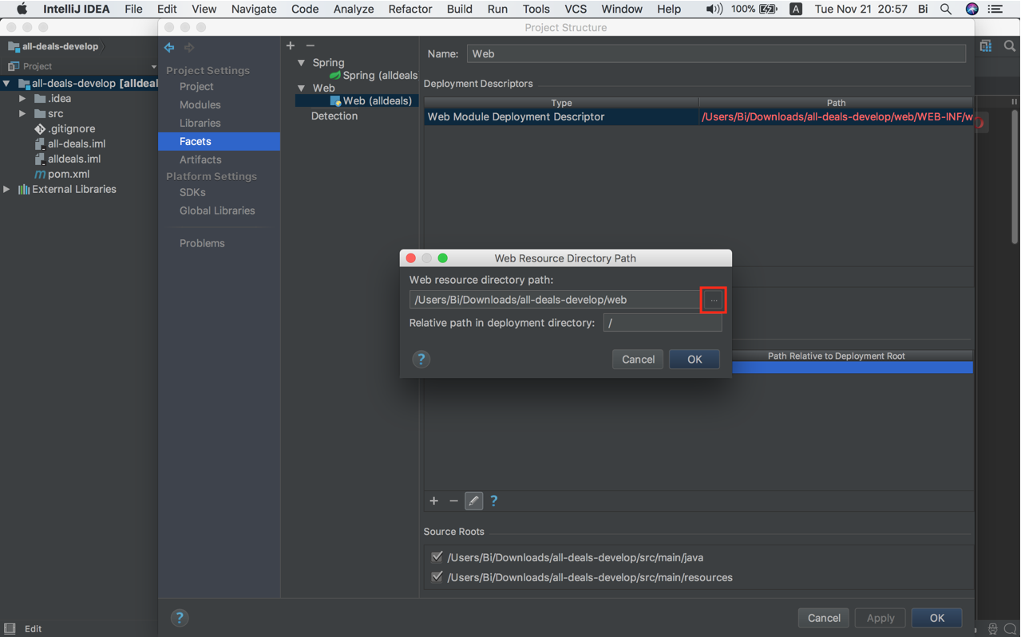

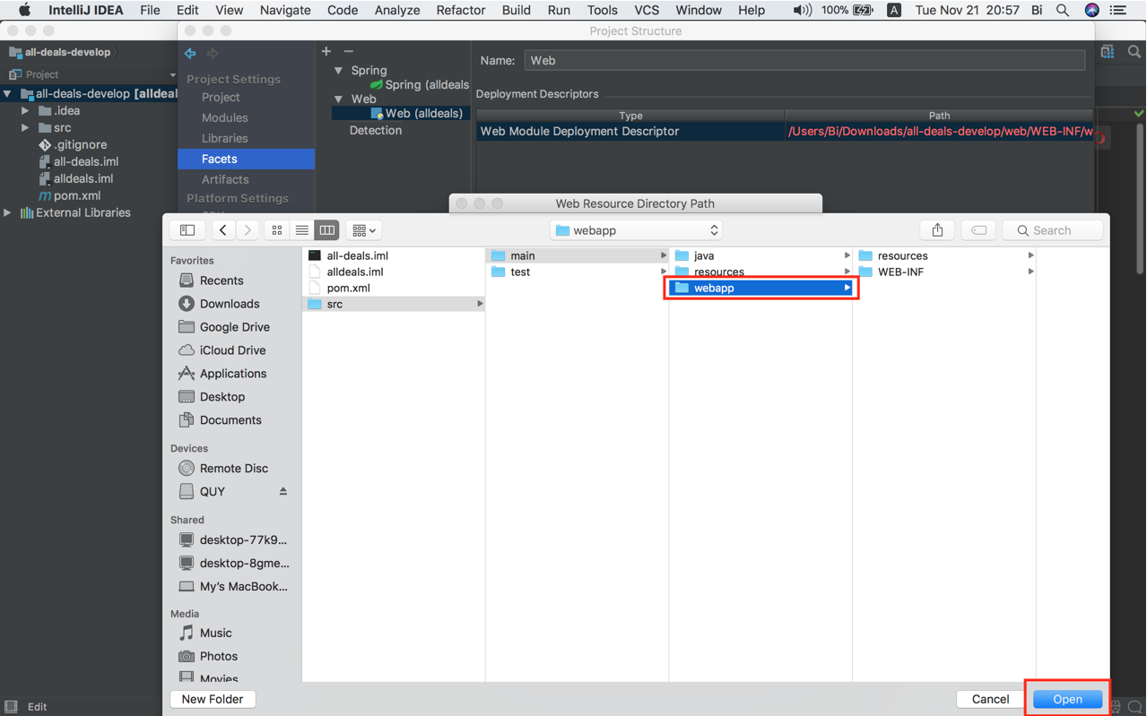

# Setup Glassfish Server

## Select Edit configurations…

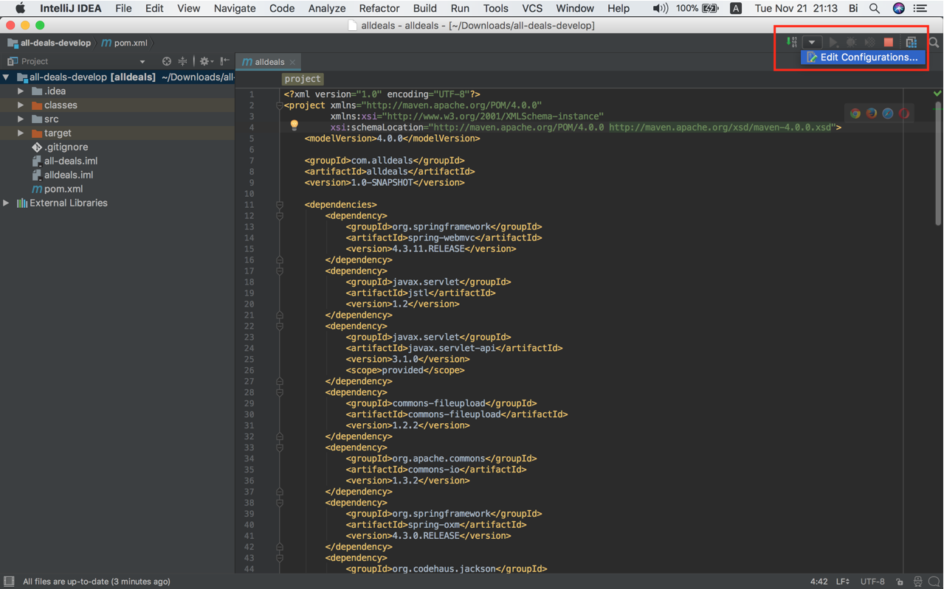

## Select + button -> GlassFish Server -> Local

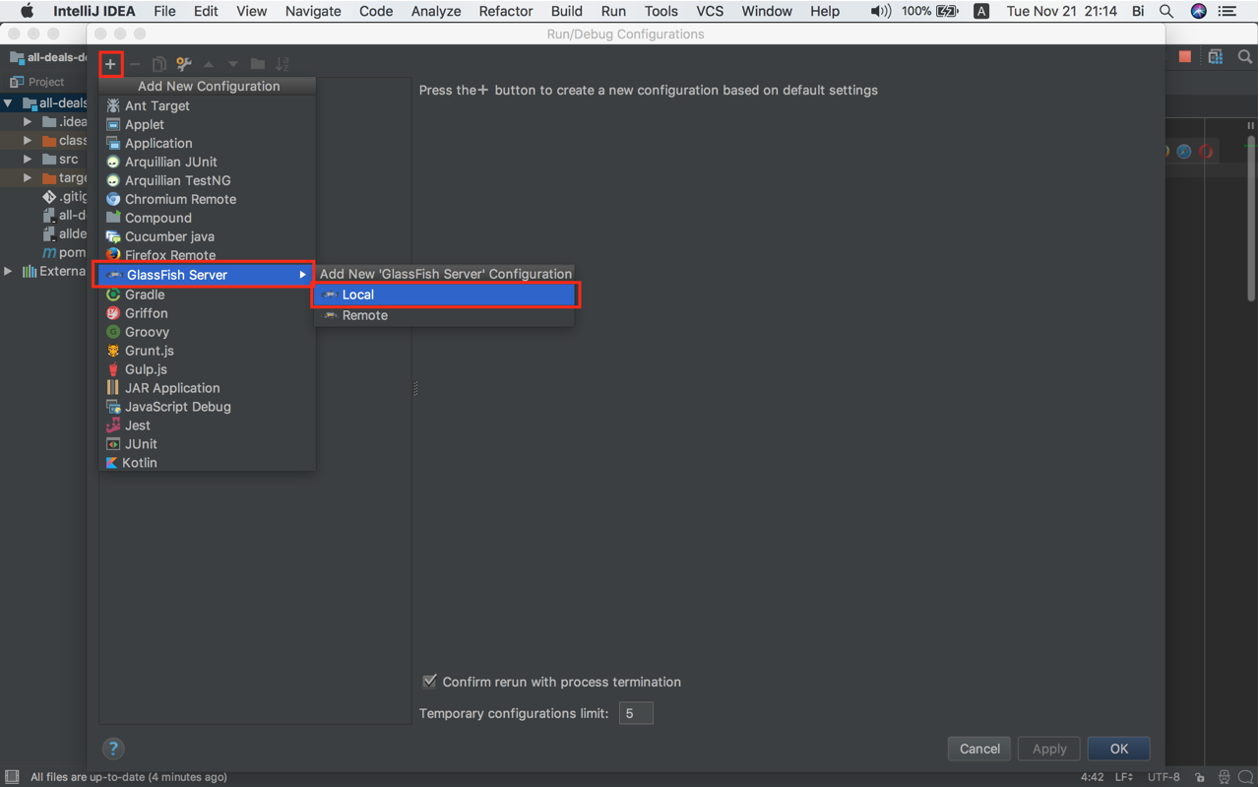

## Give a name for the Server -> Select the folder contains the GlassFish server on hard drive -> Select domain -> Click Fix to create Artifacts

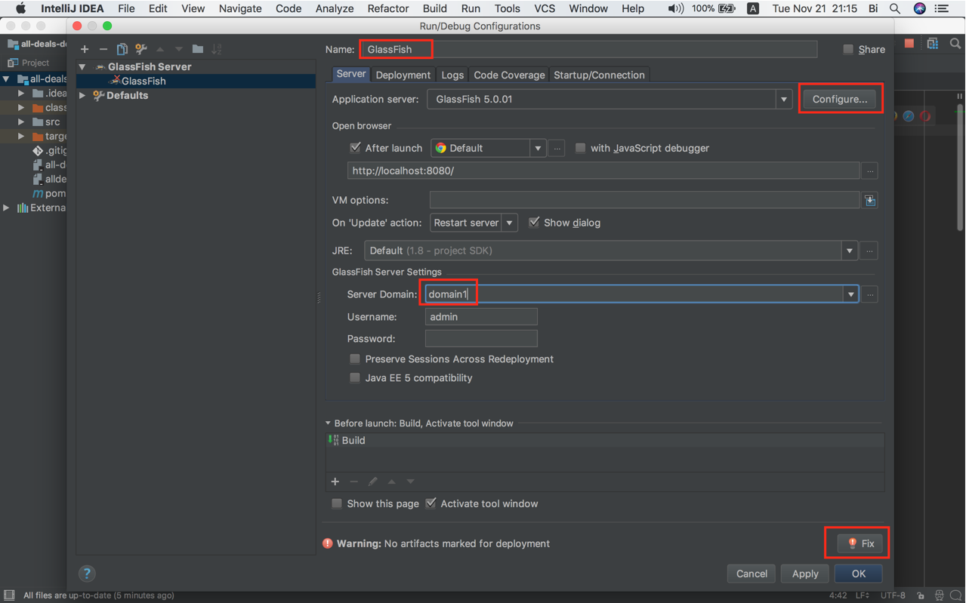

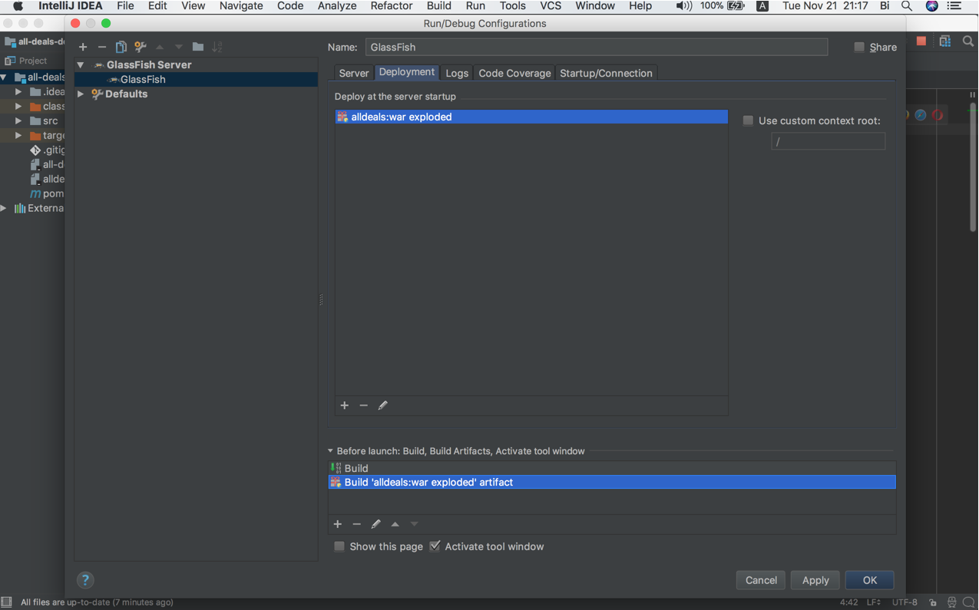

## Put all Maven dependencies to “WEB-INF/lib” folder

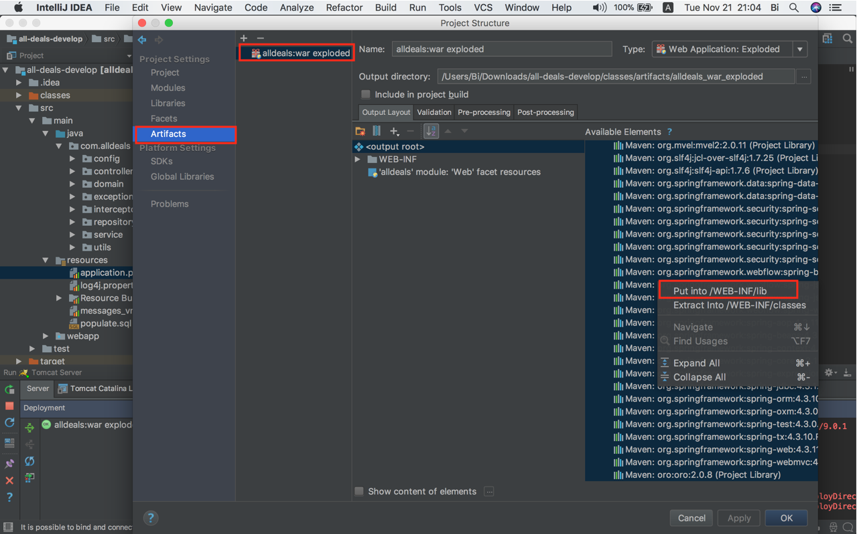

# Configure the database

## Configure database information in *application.properties* file

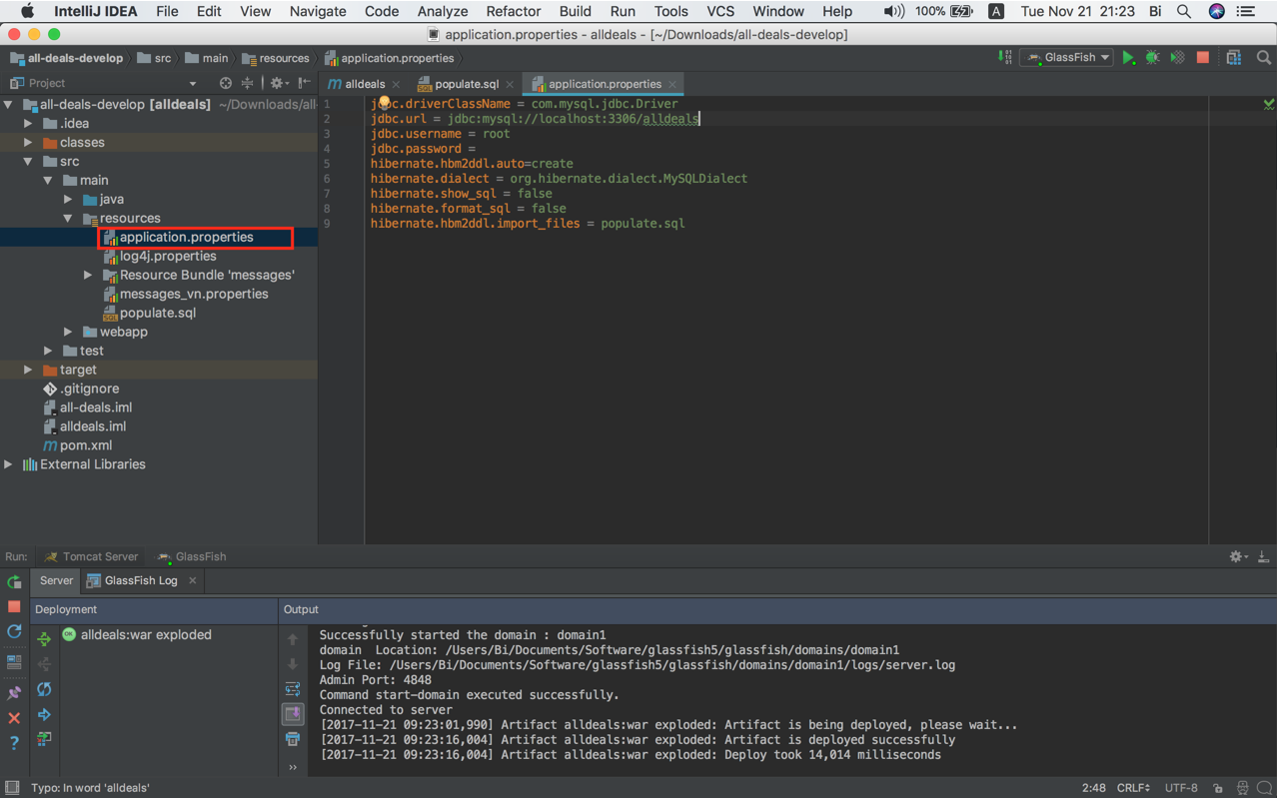

## Create a database name *alldeals*

## Run project to create tables

## Copy all the query in populate.sql and run it in MySQL client e.g: MySQL Workbench